Image | 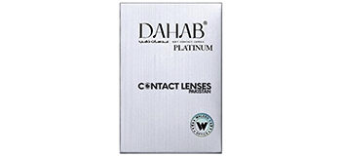
Brand | TIFFANY & CO.
Model Name | DAHAB PLATINUM
Price | RS 3860
PRODUCT DETAILS

